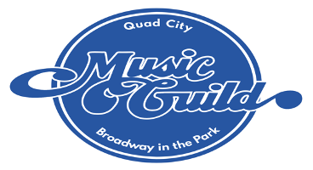
YOUTH CHORUS AUDITION INFORMATION

Please print or type clearly

Name __________________________________________________________ Age ______

School __________________________________________________________ 26/27 School Year Grade _____

Parent/Guardian Name(s) ___________________________________________________________________

Phone # ___________________________________ Phone # ______________________________________

Home Address __________________________ City ______________________ State ____ Zip _______

Email Address of contact adult________________________________________________________________
PLEASE PRINT

What is your shirt Size: Y S (6-8) Y M (10-12) Y L (14-16) A S A M A L A XL
(CIRCLE ONE)

SCHEDULE:
Rehearsals will be Monday afternoons beginning August 24th, from either 4:15-5:00pm or 5:15-6:00pm depending on the voice assignment. Rehearsal times will change to full ensemble on October 19th (4:30-6:00pm). Our Fall Concert performance is planned for Saturday December 5th at 2:00pm. Only two absences allowed; the last three rehearsals are mandatory.

PLEASE LIST ANY SCHEDULING CONFLICTS WITH REHEARSALS/PERFORMANCES

_________________ ___________________ ___________________ _________________

Please list any choral experience ___________________________________________________________

_________________________________________________________________________________________

___________________________________________ _____________________________________________

How did you hear about us?___________________________________________________________________

